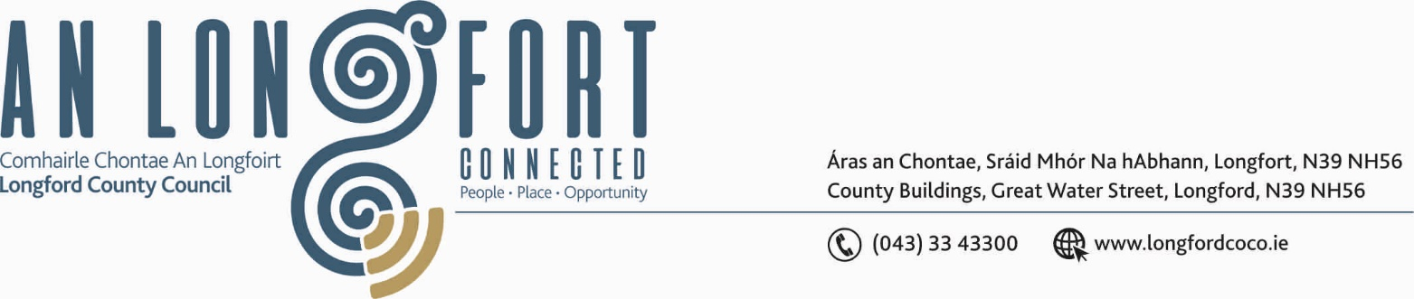

LONGFORD MUNICIPAL DISTRICT

Please note venue of Meeting –
Council Chamber, Aras an Chontae, Great Water Street.

6th February 2020.

To: Each Member of Longford Municipal District.

Dear Member,

You are requested to attend Meeting of Longford Municipal District to be held in the
Council Chamber, Aras an Chontae, Great Water Street, Longford on Wednesday,
12th February 2020 at 5.00 p.m. to transact business, as set out on the Agenda hereunder.

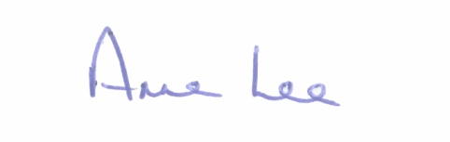
Yours sincerely,

_______________
Anne Lee,
Meetings Administrator.

AGENDA

Prayer before meeting.

- Confirmation of Minutes of Longford Municipal District Meeting held on the
22nd January 2020 – copies enclosed.

- Matters arising from Minutes.

- Declaration of Interest by Members.

- Management Report - enclosed.

- To consider and approve Schedule of Longford Municipal District Works -
Report enclosed.

- Update on Derelict Sites Register.

- Update on Memorial Wall in Ballymacormack Graveyard.

- Update on the Annaly Car Park.

- Notices of Motions, submitted by Councillors, as listed hereunder –

Councillor John Browne

“I call on Longford County Council to put in place safety measures, at the entrance to Abbeycarton from the Battery Road, in an effort to avoid accidents occurring.”

- A.O.B.



